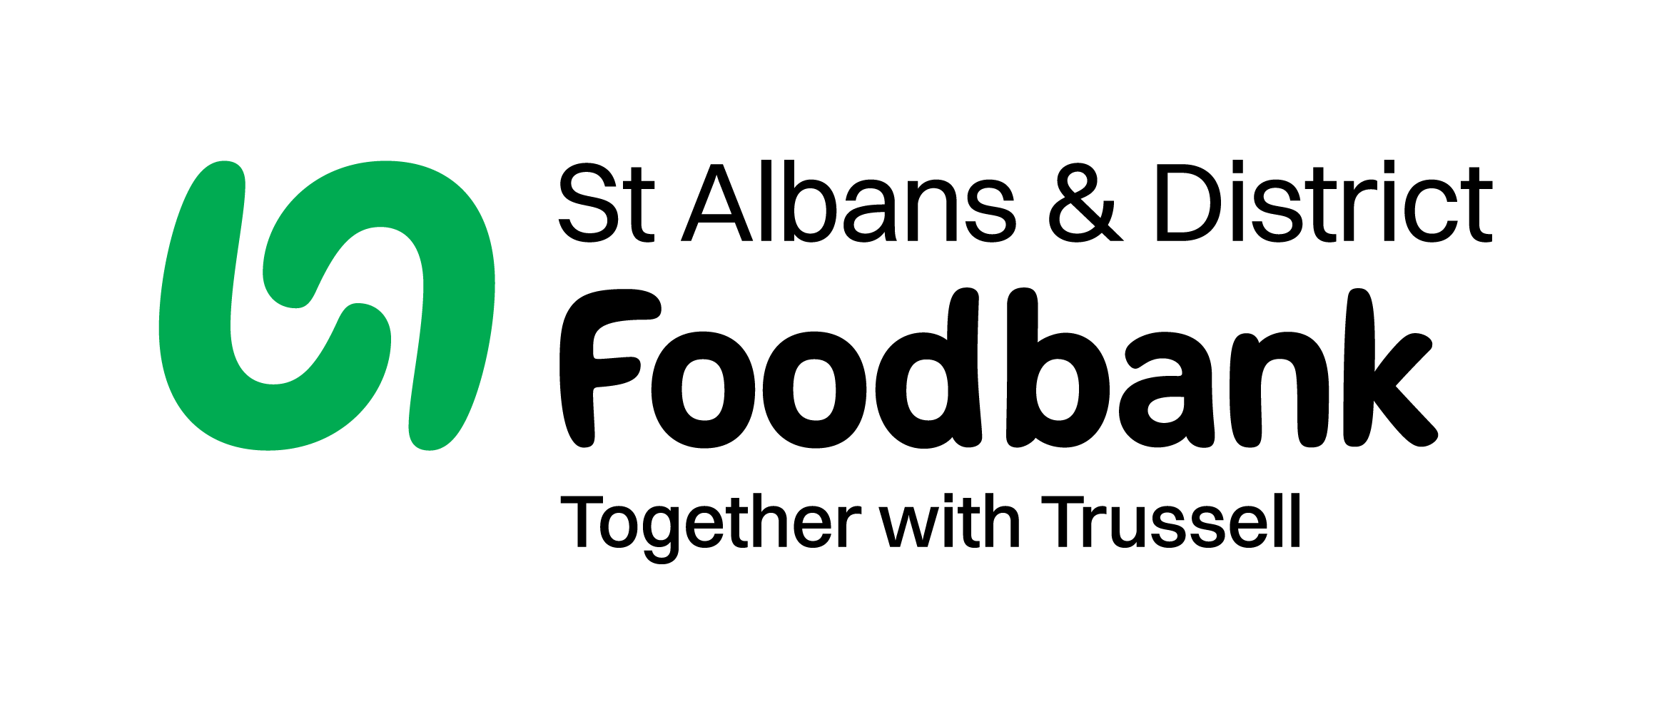
Charity Gift Aid Declaration

Boost your donation by 25p of Gift Aid for every £1 you donate

Gift Aid is reclaimed by the charity from the tax you pay for the current tax year. Your address is needed to identify you as a current UK taxpayer.

To Gift Aid your donation you must tick here: ____

I want to Gift Aid my donation of £______________ and any donations I make in the future or have made in the past 4 years to St Albans & District Foodbank CIO

I am a UK taxpayer and understand that if I pay less Income Tax and/or Capital Gains Tax than the amount of Gift Aid claimed on all my donations in that tax year it is my responsibility to pay any difference.

My Details

Title ________________ First name or initial(s) ___________________________

Surname _____________________________________________________________

Full Home address ____________________________________________________________

______________________________________________________________________

Postcode __________________________ Date __________________________

We would love to keep in touch with you so that we can update you on our work. Please tick here if you would be happy to receive communications from us:

By post | By email | I do not wish to receive future communications from St Albans & District Foodbank

Please notify us if you:

- want to cancel this declaration
- amend your communication preferences
- change your name or home address
- no longer pay sufficient tax on your income and/or capital gains

You can do this by contacting us at on 01727 613019 or by emailing us at info@stalbansdistrict.foodbank.org.uk

If you pay Income Tax at the higher or additional rate and want to receive the additional tax relief due to you, you must include all your Gift Aid donations on your Self-Assessment tax return or ask HM Revenue and Customs to adjust your tax code.

When completed please email this form to info@stalbansdistrict.foodbank.org.uk or print it and mail it to St Albans & District Foodbank, Unit 3, Redbourn Industrial Park, Redbourn AL3 7LG

