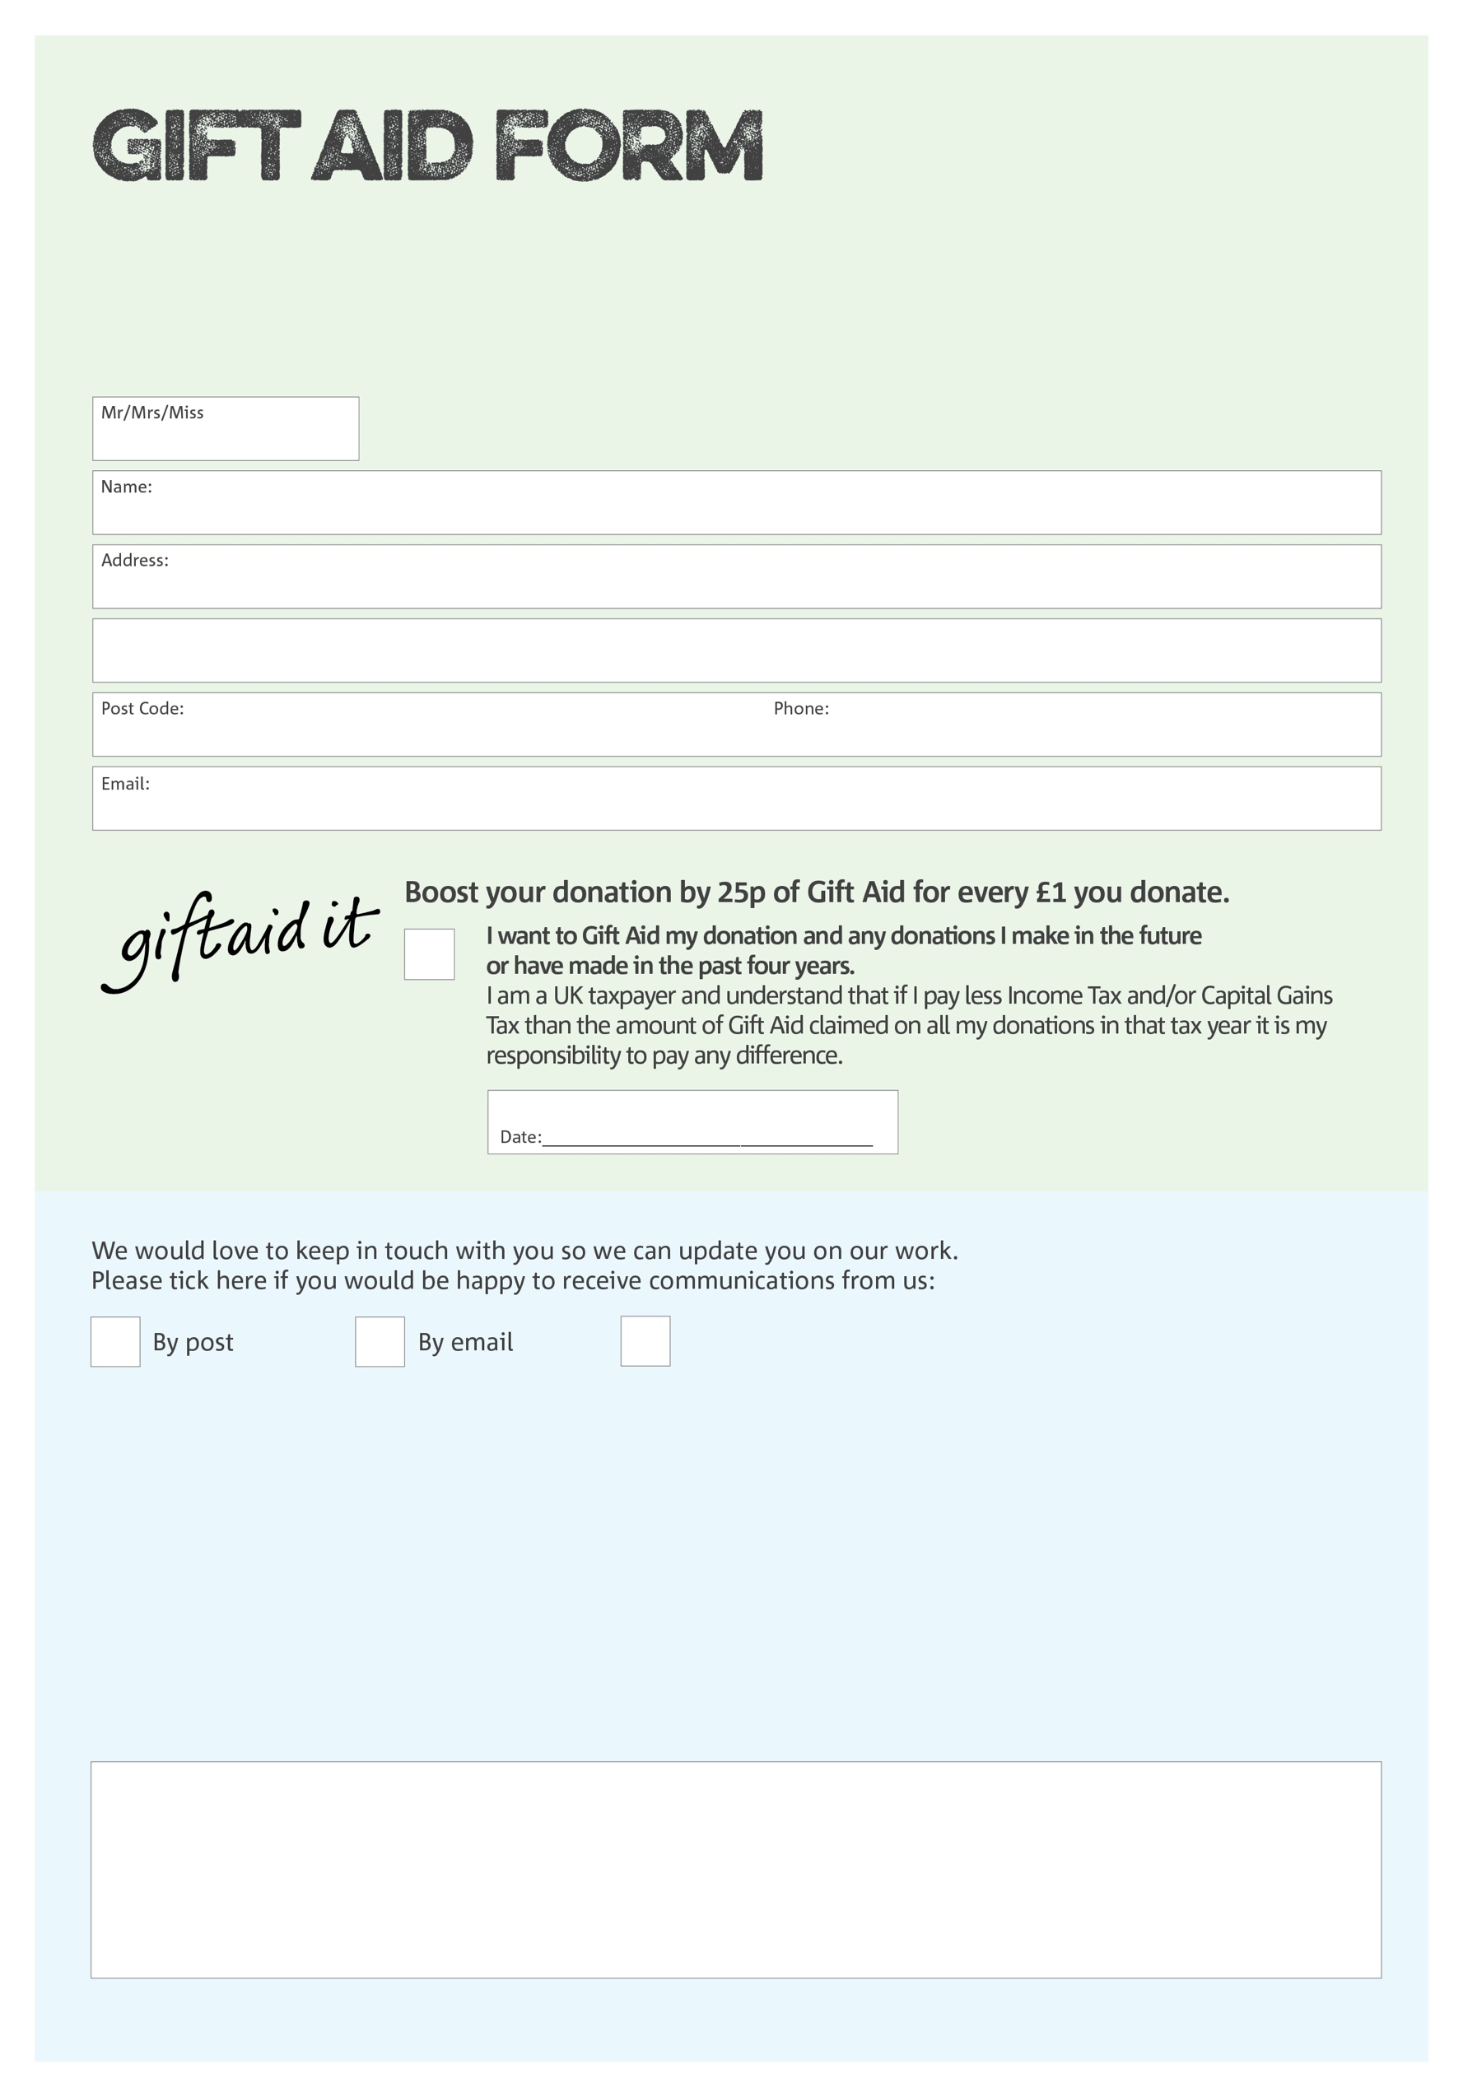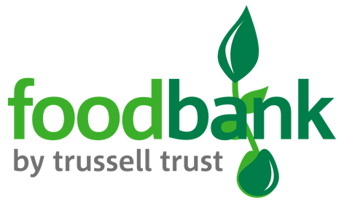

By filling in this form St Albans & District Foodbank will receive an extra 25p for every £1 you give at no extra cost to you. Thank you!

You can change your preferences any time by contacting us on 01727 613019 or emailing us at

[info@stalbansdistrict.foodbank.org.uk](mailto:info@stalbansdistrict.foodbank.org.uk).

Please email this form to [info@stalbansdistrict.foodbank.org.uk](mailto:info@stalbansdistrict.foodbank.org.uk) or mail to St Albans & District Foodbank, Unit 3, Redbourn Industrial Park, Redbourn, Hertfordshire AL3 7LG

**Data protection**

*St Albans & District Foodbank is committed to protecting your privacy and will process your personal data in accordance with current Data Protection legislation. St Albans & District Foodbank collects information to keep in touch with you and supply you with information relating to our work. To unsubscribe from our newsletter, send a message to the email address above with the word unsubscribe in the subject line. A full data privacy statement for financial donors is available from the foodbank on request.’*

I do not wish to receive future communications from St Albans & District Foodbank

Charity Number 1158917. Registered in England & Wales

We would love to know why you have chosen to donate to St Albans & District Foodbank. If you would like to share your motivation let us know below: