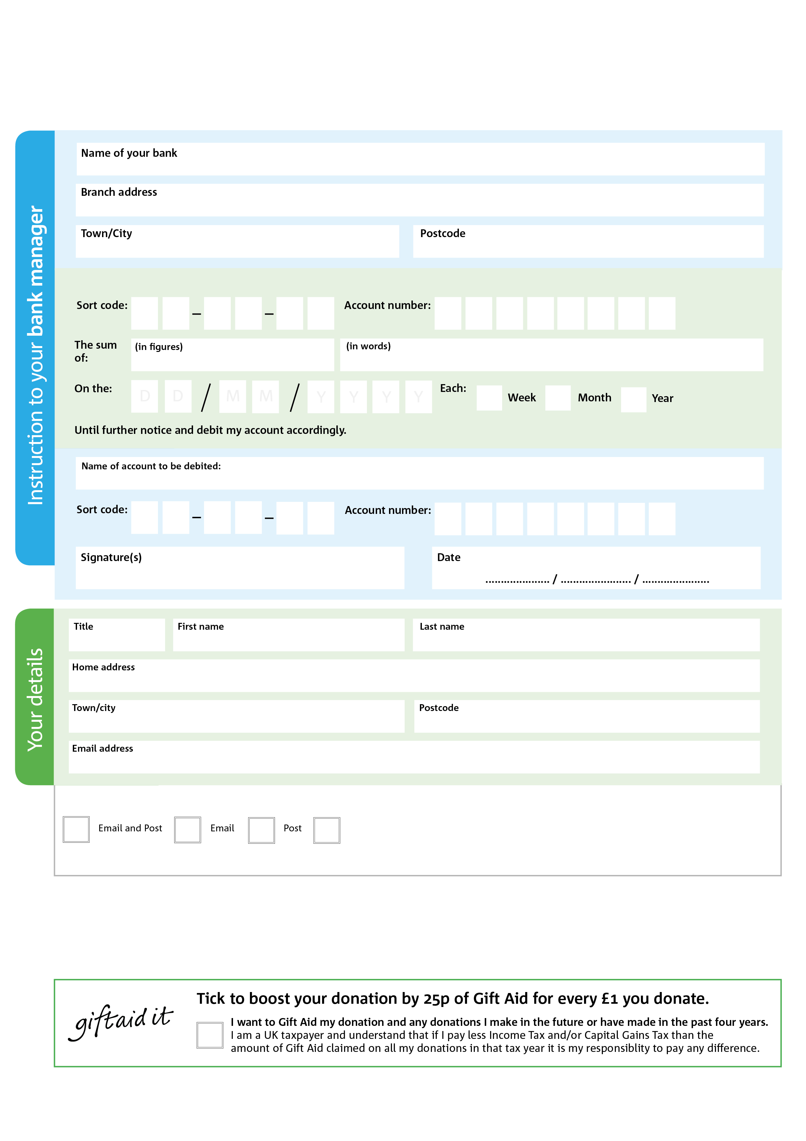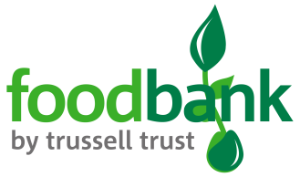

Reg. Charity No: 1158917 | Reg. in England & Wales

POSTAL ADDRESS: St Albans and District Foodbank, Youth with a Mission, 6 Highfield Oval, Harpenden, Herts, AL5 4BX

Please pay St Albans and District Foodbank

**Please pass this form onto the foodbank, using the foodbank’s address at the bottom, who will save a copy for their records. They will then send it onto your named bank or building society.**

3

V

7

V

7

V

5

V

2

V

0

V

0

V

00025773X

V

0

4

2

5

0

4

We would love to keep you up to date with information about St Albans and District Foodbank. Please tick your preference:

You can change your preferences any time by contacting us on [01727 613019](tel:01727%20613019) or emailing us at [info@stalbansdistrict.foodbank.org.uk](mailto:info@stalbansdistrict.foodbank.org.uk)

I do not wish to receive future communications from St Albans and District Foodbank

**Data protection**

St Albans and District Foodbank is committed to protecting your privacy and will process your personal data in accordance with the Data Protection Act 1998. St Albans and District Foodbank collects information to keep in touch with you and supply you with information relating to our work. St Albans and District Foodbank will never sell or pass your details to anyone who isn’t directly working on our behalf.

**Standing Order Mandate**

**stalbansdistrict.foodbank.org.uk**

You can change your preferences any time by contacting us on XXXXXXXXXXX or emailing us at XXXX@XXXXXXXXXX.foodbank.org.uk

I do not wish to receive future communications from XXXXXX Foodbank